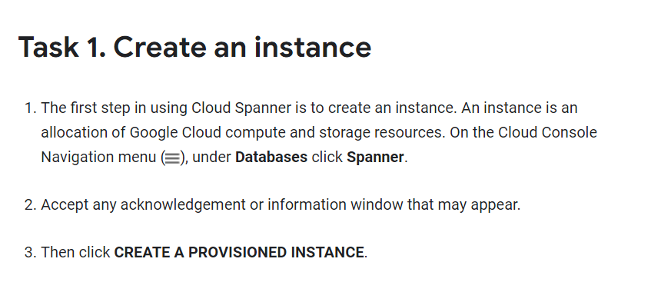

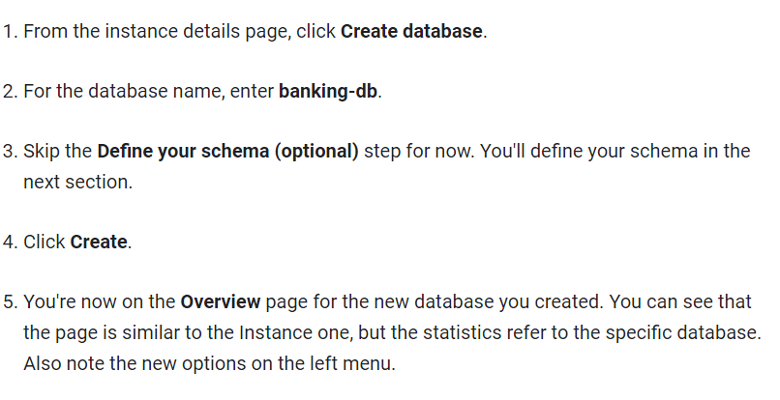

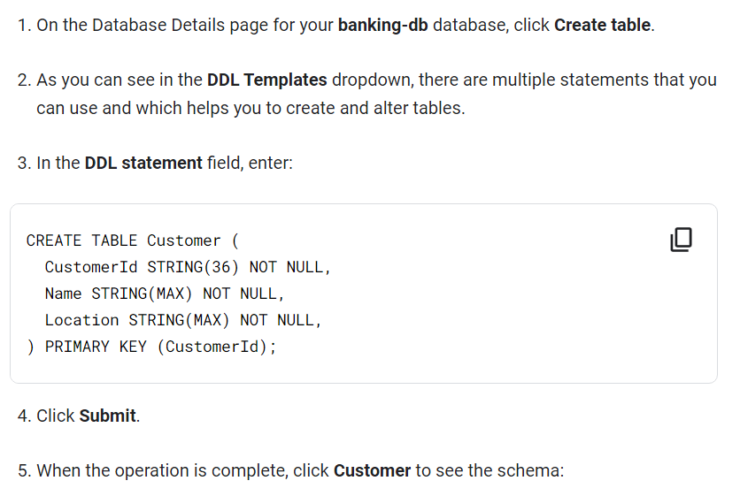

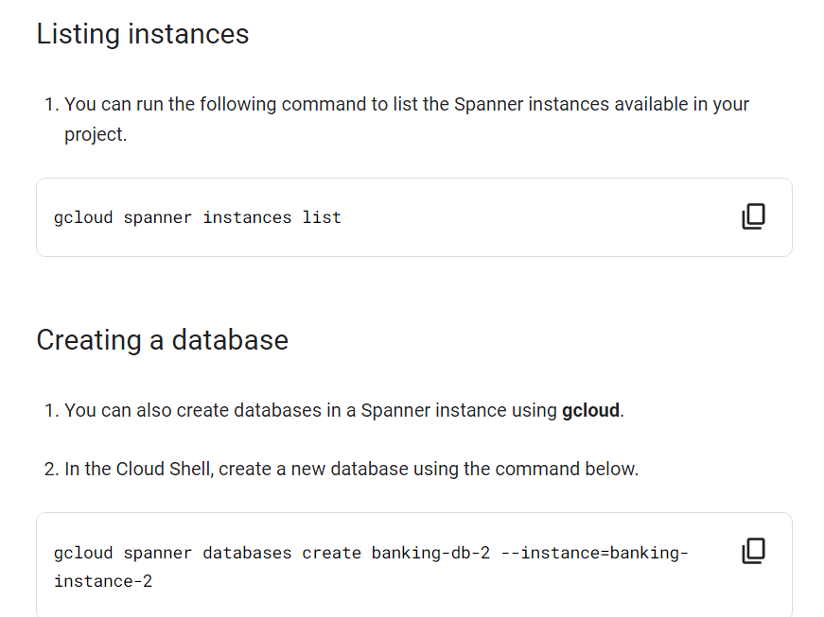

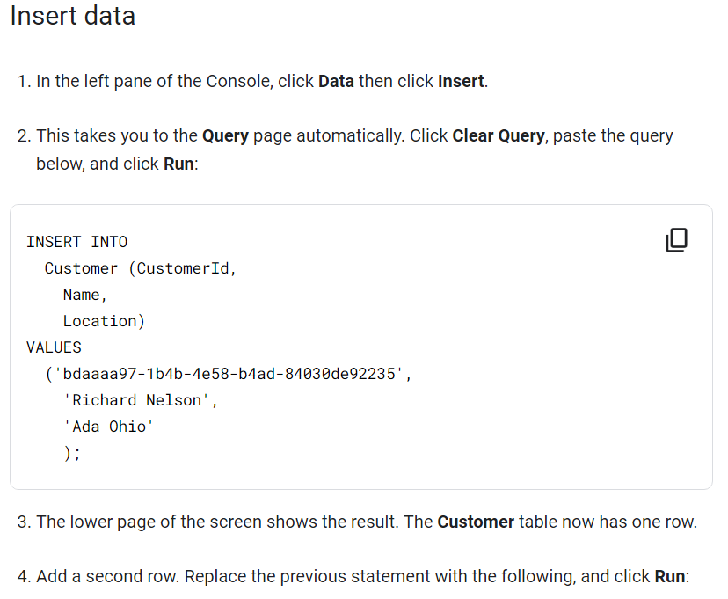

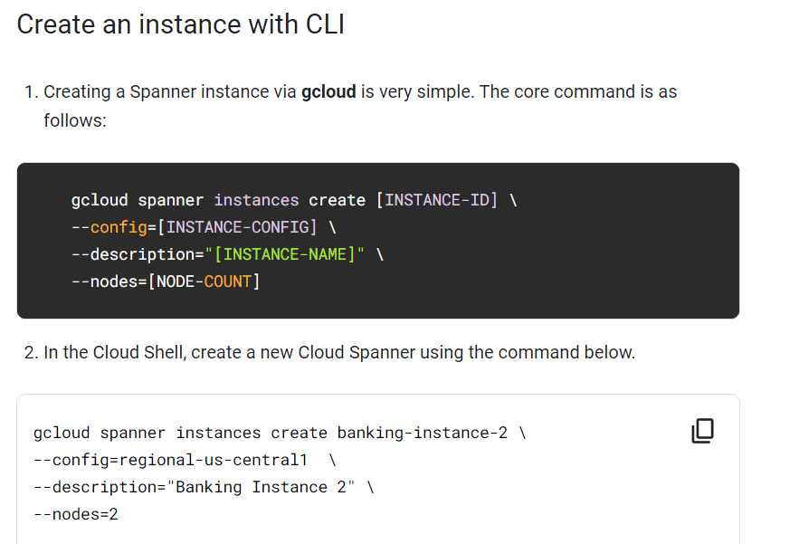



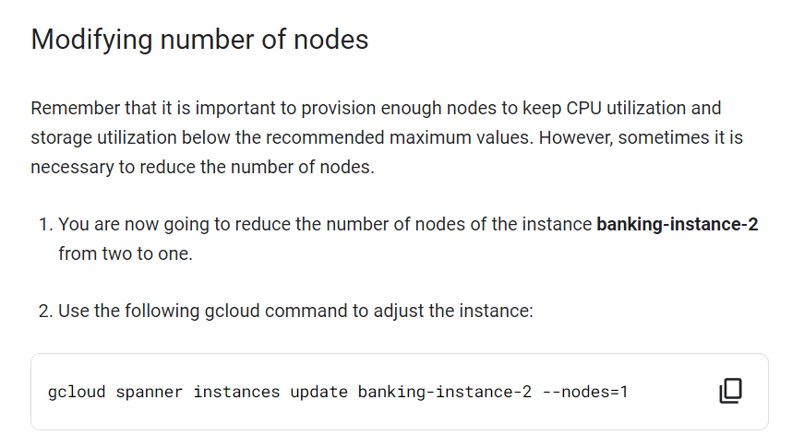

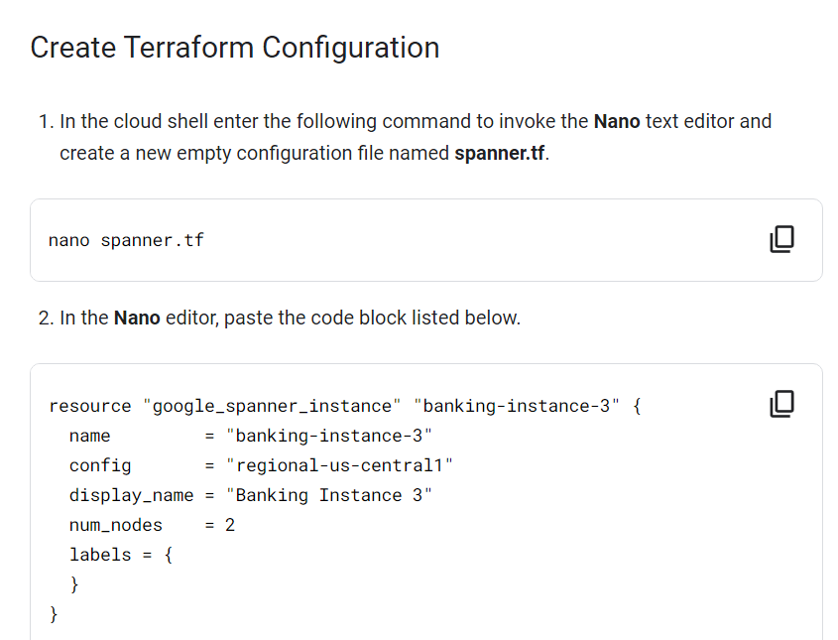

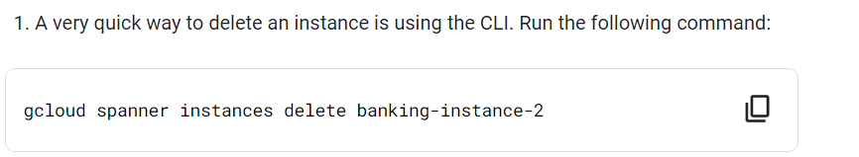

DML with Gcloud

gcloud spanner databases execute-sql banking-db --instance=banking-instance \

--sql="INSERT INTO Customer (CustomerId, Name, Location) VALUES ('bdaaaa97-1b4b-4e58-b4ad-84030de92235', 'Richard Nelson', 'Ada Ohio')"

**Insert data through a client library**

nano insert.py

from google.cloud import spanner

from google.cloud.spanner_v1 import param_types

INSTANCE_ID = "banking-instance"

DATABASE_ID = "banking-db"

spanner_client = spanner.Client()

instance = spanner_client.instance(INSTANCE_ID)

database = instance.database(DATABASE_ID)

def insert_customer(transaction):

row_ct = transaction.execute_update(

"INSERT INTO Customer (CustomerId, Name, Location)"

"VALUES ('b2b4002d-7813-4551-b83b-366ef95f9273', 'Shana Underwood', 'Ely Iowa')"

)

print("{} record(s) inserted.".format(row_ct))

database.run_in_transaction(insert_customer)

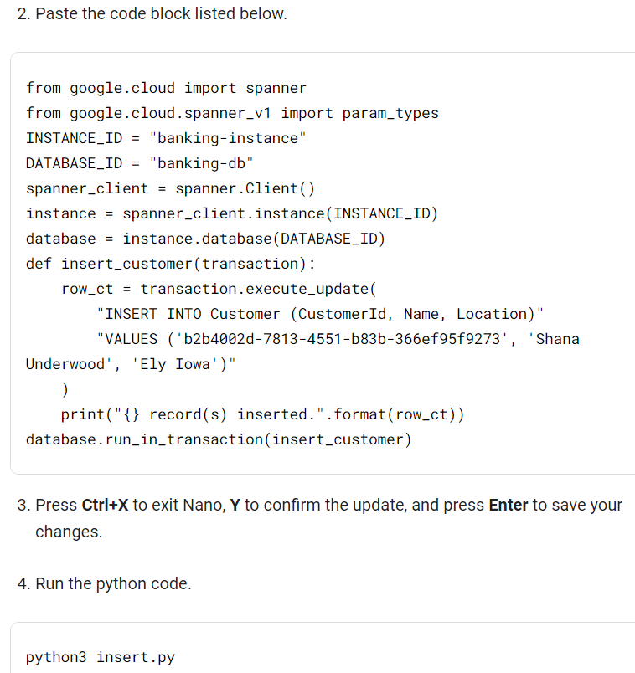

## Insert batch data through a client library

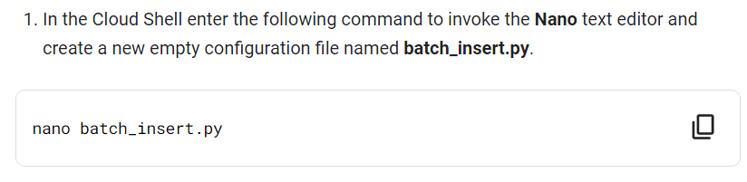

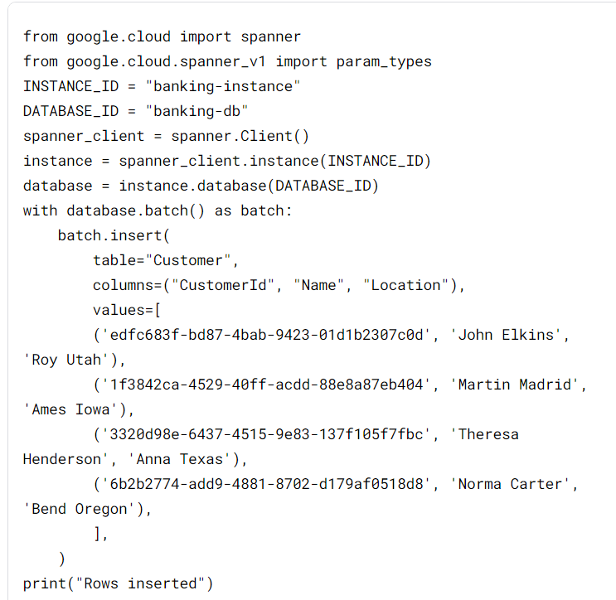

python3 batch_insert.py

